# Week:03-01

### Q1)ProblemStatement:

Writeaprogramtoreadtwointegervaluesandprinttrueifboththenumbersendwiththe same digit, otherwise print false.

Example:II698and768aregiven,programshouldprinttrueas theybothendwith8.

### SampleInput1

2553

### SampleOutput1

false

### SampleInput2

2777

### SampleOutput2

true

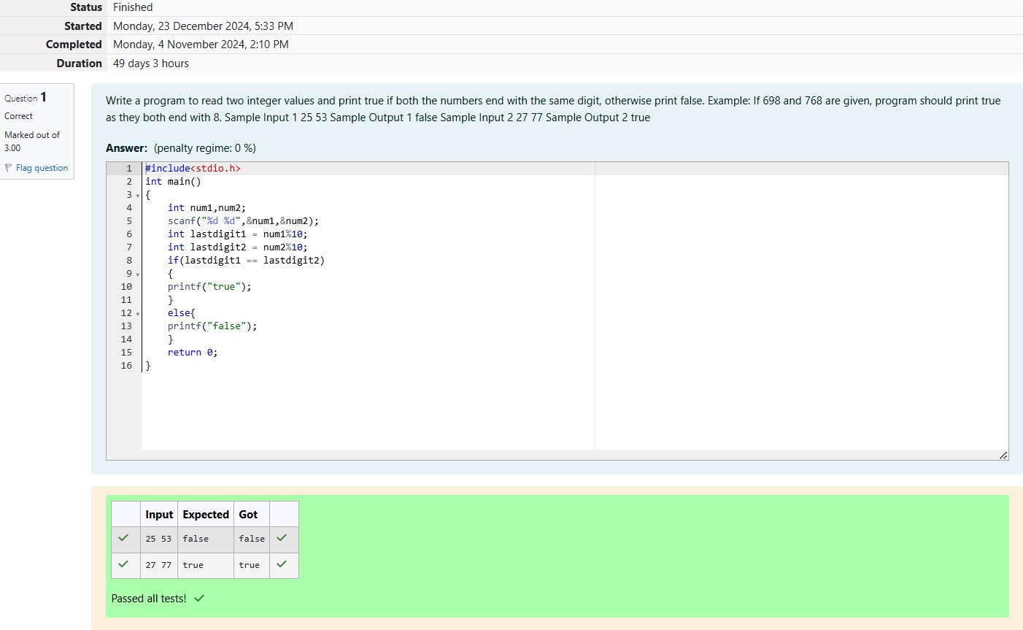

### Q2)ProblemStatement:

Inthischallenge,we'regettingstartedwithconditionalstatements.

### Task

Givenaninteger,n,performthefollowingconditionalactions:

Ifnisodd,print Weird

Ifnisevenandintheinclusiverangeof2to 5,printNotWeird If n is even and in the inclusive range of 6 to 20, print Weird

Ifnisevenandgreaterthan20,printNot Weird

Completethestubcodeprovidedinyoureditor toprintwhetherornotnisweird.

# InputFormat

Asinglelinecontainingapositiveinteger,n. Constraints

1<n<100

# OutputFormat

PrintWeirdifthenumberisweird;otherwise,printNotWeird.

### SampleInput0

3

### SampleOutput0

Weird

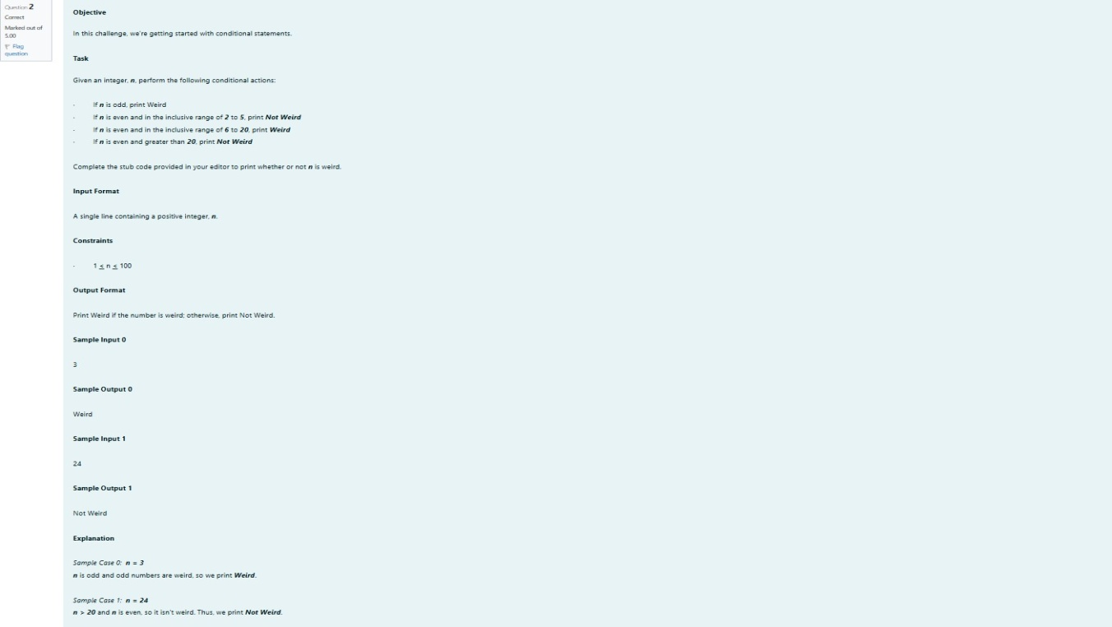

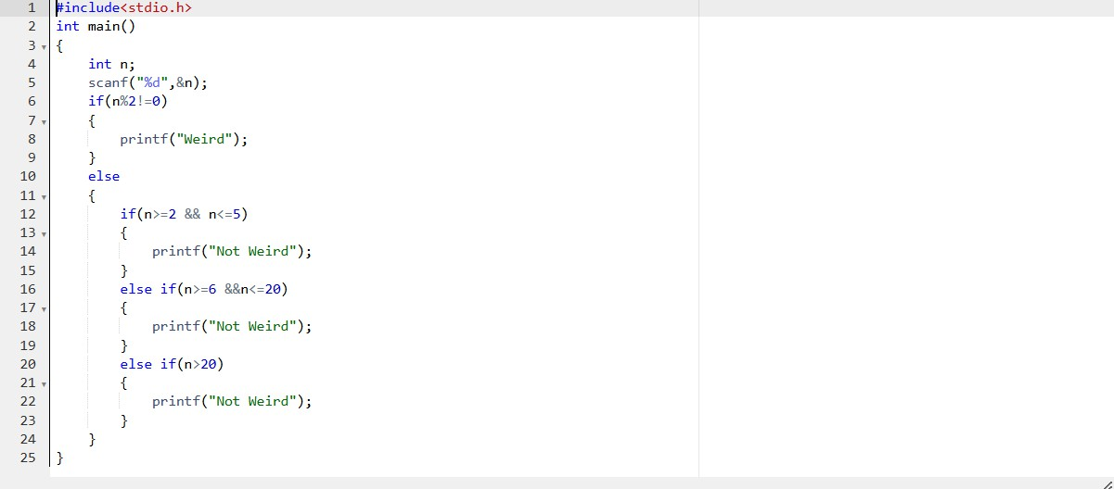

## OUTPUT:

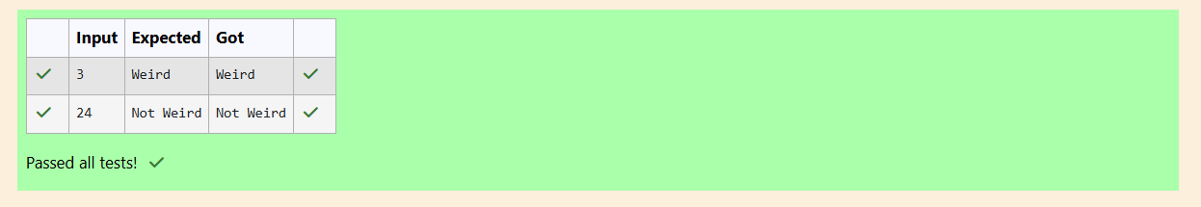

### Q3)ProblemStatement:

ThreenumbersformaPythagoreantripleifthesumof squaresoftwo numbersisequaltothe square of the third.

Forexample,3,5and4 formaPythagoreantriple,since3*3+4*4=25=6*5

You are given three integers, a, b, and e. They need not be given in increasing order. If they form a Pythagoreantriple,thenprint"yes",otherwise,print"no".Pleasenotethattheoutputmessageisin smallletters.

### SampleInput1

3

5

4

### SampleOutput1

Yes

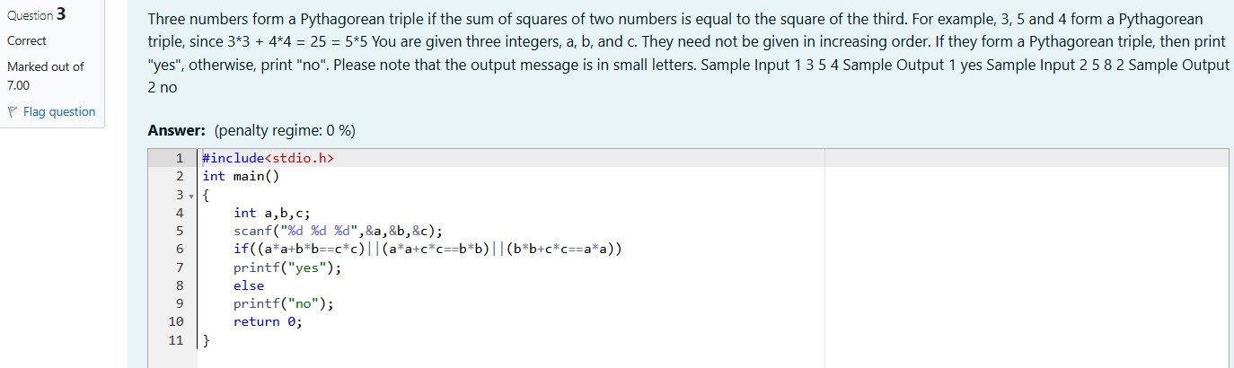

OUTPUT:

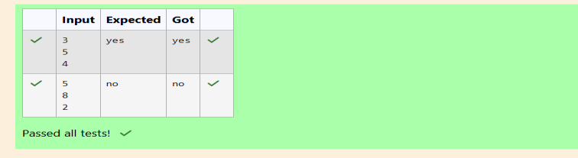

# Week:03-02

### Q1)ProblemStatement:

Writeaprogramthatdeterminesthenameofashape fromitsnumberofsides.Readthenumberof sides from the user and then report the appropriate name as part of a meaningful message. Your program should supportshapes with anywhere from 3 up to (andincluding) 10sides. If a number of sides outside of this range is entered then your program should display an appropriate error

message.

### SampleInput1

3

### SampleOutput1

Triangle

### SampleInput2

7

### SampleOutput2

Heptagon

### SampleInput 3

11

### SampleOutput3

Thenumberofsidesisnotsupported.

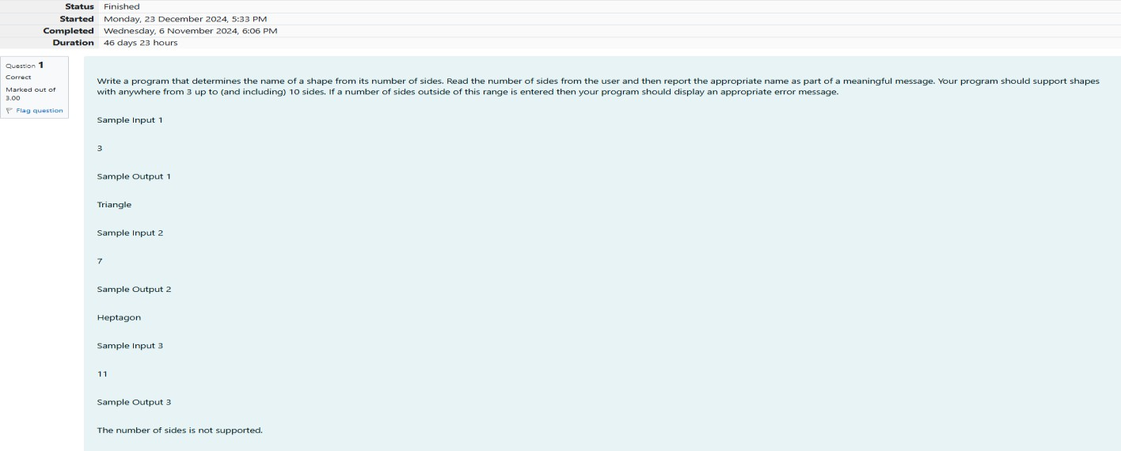

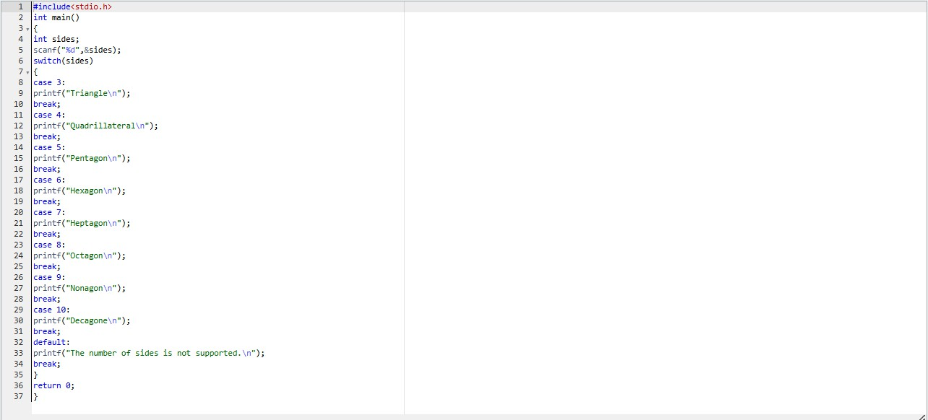

## OUTPUT:

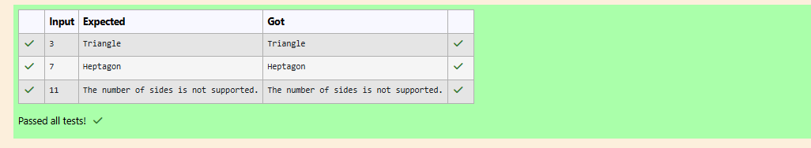

### Q2)ProblemStatement:

The Chinese zodiac assigns animals to years in a 12-year cycle. One 12-year cycle is shown in the tablebelow.Thepatternrepeatsfromthere,with 2012beinganotheryearoftheDragon,and1999 being another year of the Hare.

YearAnimal

|  |  |
| --- | --- |
| 2000 | Dragon |
| 2001 | Snake |
| 2002 | Horne |
| 2003 | Sheep |
| 2004 | Monkey |
| 2005 | Rooster |
| 2006 | Dog |
| 2007 | Pig |
| 2008 | Rat |
| 2009 | Ox |

2010Tiger

2011Hare

Writeaprogramthatreadsayearfrom theuseranddisplaystheanimalassociatedwiththatyear. Your program should work correctly for any year greater than or equal to zero, not just the ones listed in the table.

### SampleInput1

2004

### SampleOutput1

Monkey

### SampleInput2

2010

### SampleOutput2

Tiger

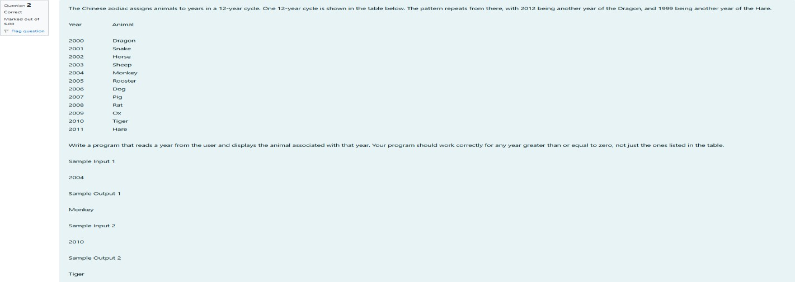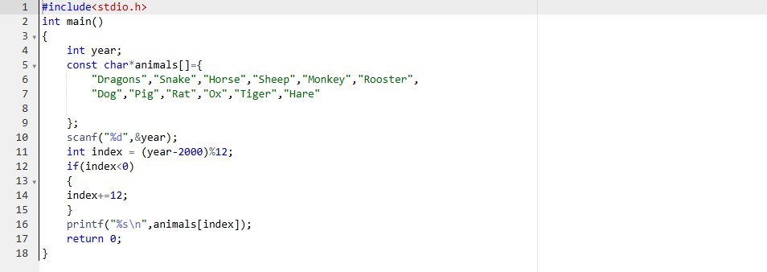

## OUTPUT:

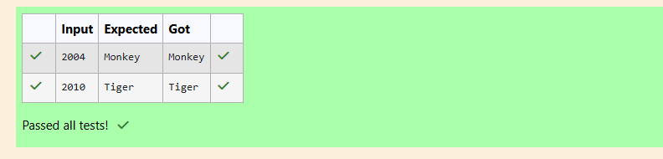

### Q3)ProblemStatement:

Positionsonachessboardareidentifiedbyaletterandanumber.Theletteridentifiesthecolumn, while the number identifies the row,

Writeaprogramthatreadsapositionfrom theuser.Useanifstatementto determineifthecolumn beginswithablacksquareorawhitesquare.Thenuse modulararithmetictoreportthecolor ofthe square in that row. For example, if the user enters al then your program should report that the

squareisblack.Iftheuserentersd5 thenyourprogramshouldreportthat the squareiswhite.Your program may assume that a valid position will always be entered. It does not need to perform any error checking.

### SampleInput1

A1

Sample Output 1 Thesquareisblack. Sample Input 2

D5

### SampleOutput2

Thesquareiswhite.

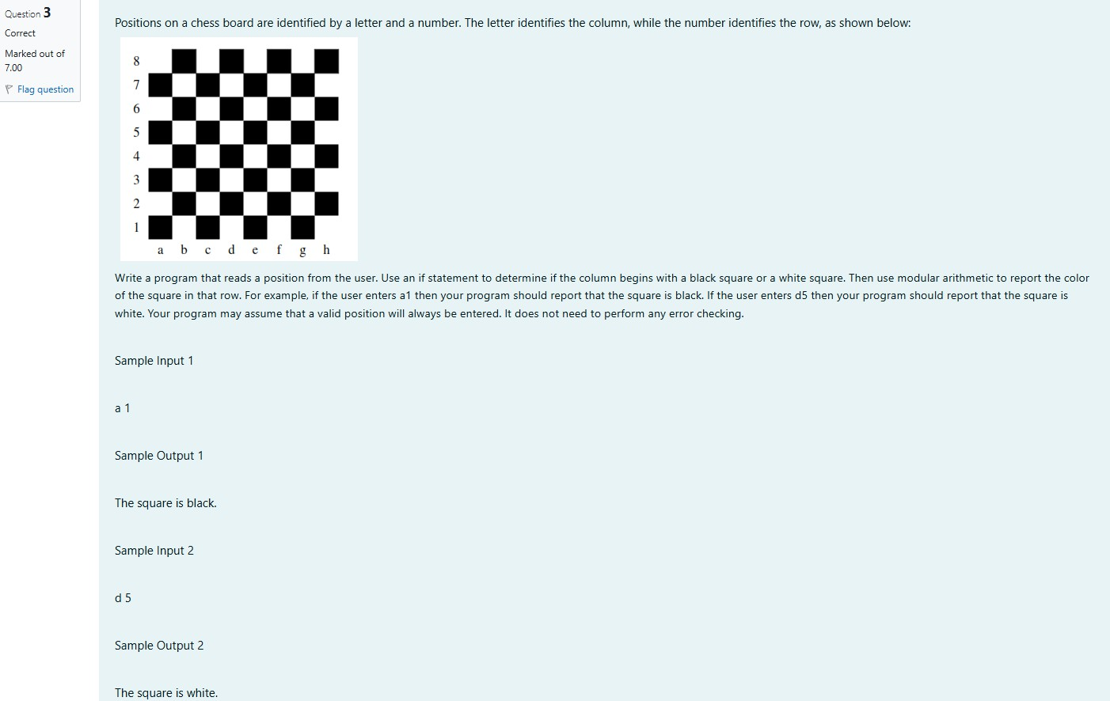

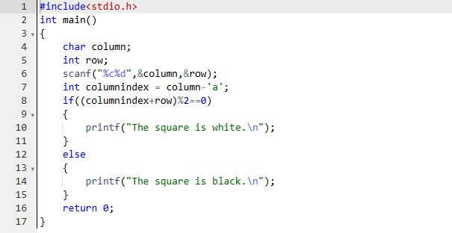

OUTPUT:

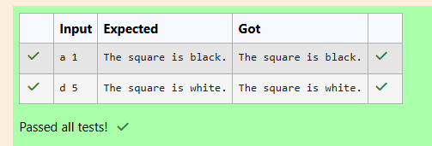

# Week:03-03

### Q1)ProblemStatement:

Somedatasetsspecifydatesusingtheyearand dayof yearratherthan theyear,month,anddayof month. The day of year (DOY) is the sequential day number starting with day 1 on January 1st.

There are twocalendars - one for normal years with365days, and one for leapyears with366days. Leapyearsaredivisibleby4.Centuries,Centlike1900, arenotleapyearsunlesstheyaredivisibleby

400.So,2000wasaleapyear.

Tofind theday ofyearnumberforastandarddate,scandowntheJan columnto find thedayof month, then scan across to the appropriate month column and read the day of year number.

Reversetheprocessto findthestandarddatefora givendayofyear.Writeaprogramtoprintthe Day of Year of a given date, month and year

### SampleInput 1

18

6

2020

### SampleOutput1

170

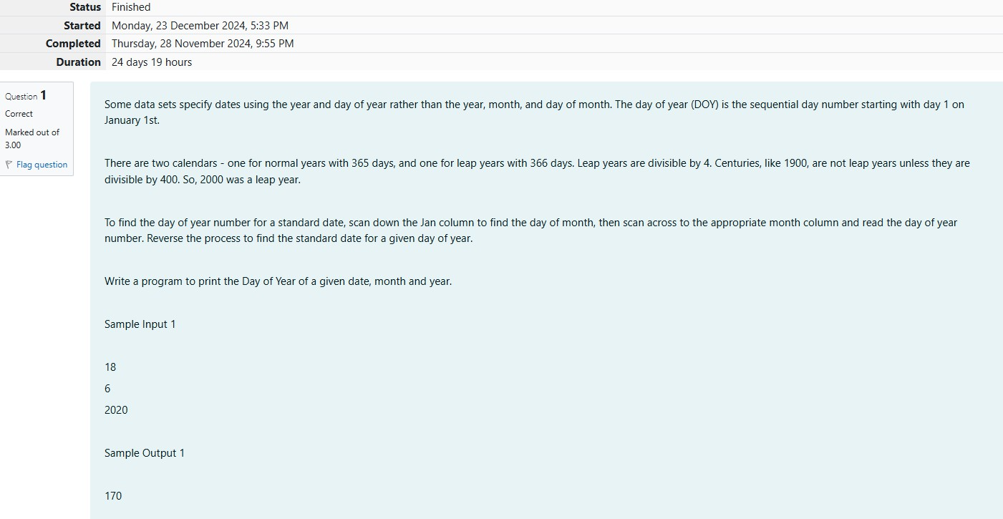

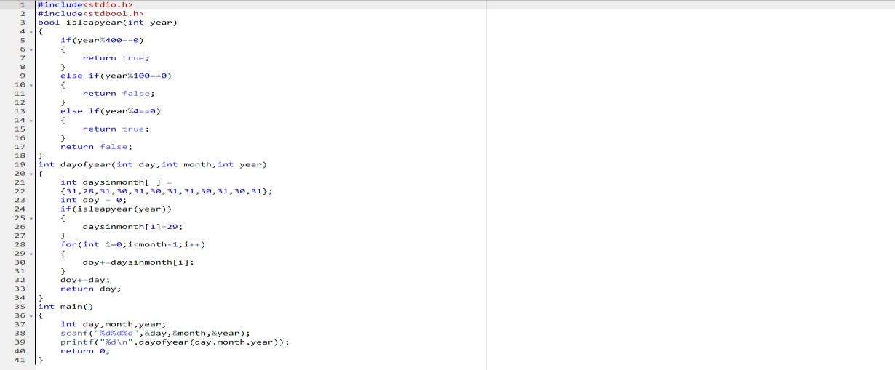

## OUTPUT:

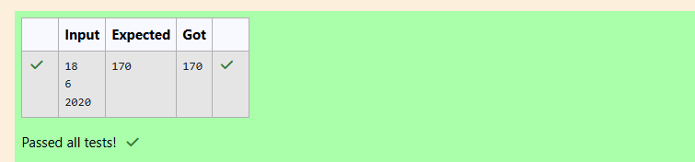

### Q2)ProblemStatement:

Suppandi istryingtotakepanin thelocalvillagemathqua.Inthefirstround, heisaskedabout shapesandareas.Suppandi,isconfused,hewasneveranygoodatmath.Andalso,heisbad at

rememberingthenamesofshapes.Instead,youwillIbehelpinghimcalculatetheareaofshapes.

* Whenhesaysrectangle,heisactuallyreferringtoasquare.
* Whenhesayssquare,heisactuallyreferringtoatriangle.
* Whenhesaystriangle,heisreferringtoarectangle
* Andwhenheisconfused,he justsayssomethingrandom.Atthispoint,allyoucan dois say 0.
* HelpSuppandibyprintingthecorrectanswerinaninteger.

### InputFormat

* Nameofshape(alwaysinuppercaseR->Rectangle,S-->Square,T->Triangle)
* Lengthof1 side
* Lengthofotherside

Note:Incaseoftriangle,youcanconsiderthesidesas heightandlengthofbase

### OutputFormat

* Printtheareaofthe shape.

### SampleInput1

T 10

20

SampleOutput1

200

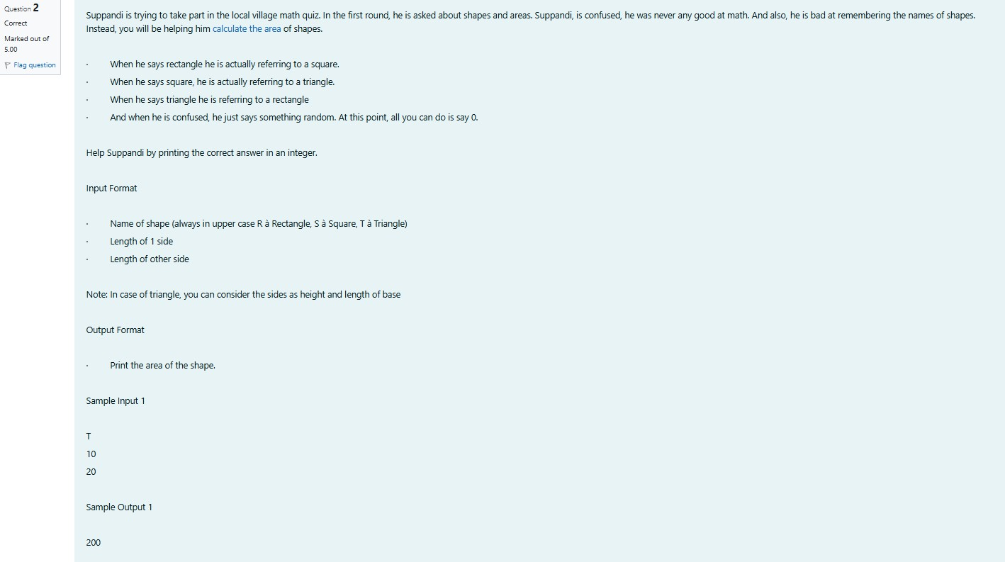

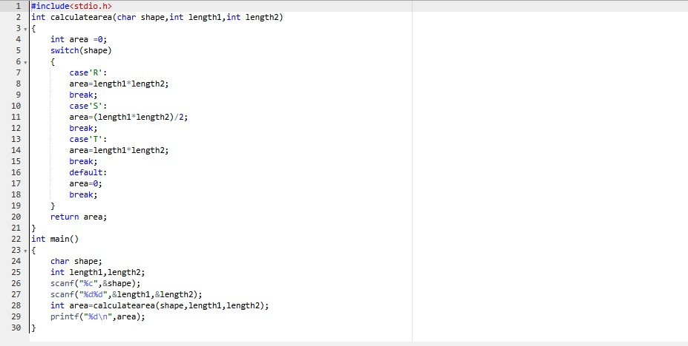

## OUTPUT:

### Q3)ProblemStatement:

superdayhearrivesthere. Theytohishomeplanet. It isveryimportant for himtoknowwhichdy week with the fou. They don't follow a 10-day following days: hitney follow

### Day NumberNameofDay

1. sunday
2. monday
3. tuesday
4. wednesday
5. thursday
6. friday
7. Saturday
8. kryptoday
9. coluday
10. daxamday

### Here arethe rulesofthecalendar:

* + Thecalendar startswithSundayalways.
  + Ithasonly296days.Afterthe296thday, it goesbacktoSunday.

Youbeginyour journeyona Sundayandwillreachafter n. Youhavetotellonwhichdayyou will arrive when you reach there.

### Inputformat:

Containanumber n(0<n)

### Outputformat:

Print thenameofthedayyou arearriving on

### SampleInput

7

SampleOutput Kryptonday Sample Input1

### SampleOutput

Monday

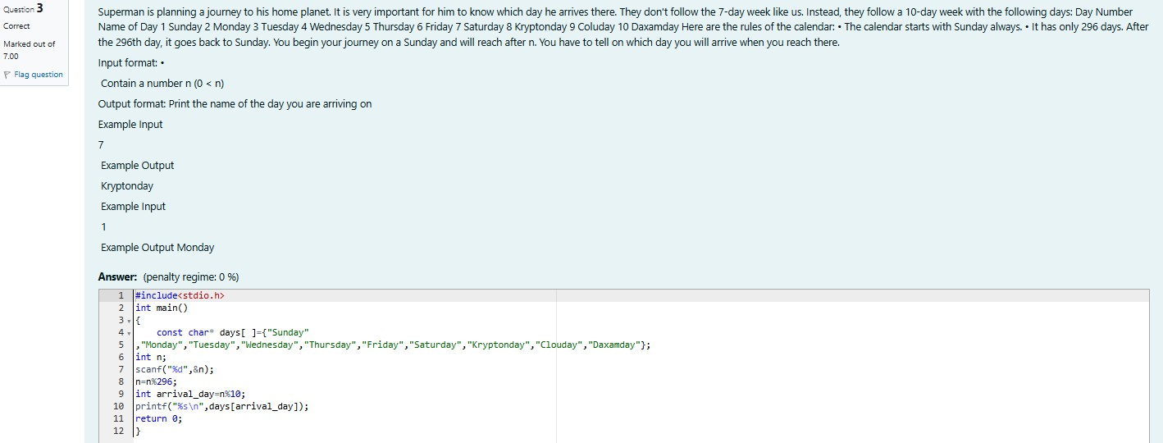

OUTPUT:

